DougieBase

A DataBase. A PWA coded in JavaScript and jQuery



Doug Dyer Victoria BC

**Chapter 2**

TAble of  
Contents

Chapter 1

Dougiebase

Introduction 1

What can it do ? 1

Features 2

Installation 3

Connect to the web server

About the Service Worker

Add to Home Screen ………….……………………………………………. 4

**Initial steps to get started……………………….. 4**

The first window. ………….……………………………………………

Create New DB. ………………………………………………………… 5

Rename the database. …………………………………………… 7

Create first Note/Record. ………………………………………… 9

Create the second data field. …………………………………… 10

Preferences ……………………………………………… 14

SHOW and HIDE options …………………………………………………. 14

Make SEARCH Case Sensitive. ………………………………………… 14

Include time in table date edit …………………………………………… 14

Change Colours. ……………………………………………………………… 15

A word about the SCROLL buttons ………………………………… 16

Add Note ………………………………………………. 17

Create a new record or note…………………………………………………18

The second notes data field ………………………………………… 18

Add date. …………………………………………………………………………. 19

The colon delimiter ………………………………………………………. 19

Note options ………………………………………………………………. 19

Delete Record. ………………………………………………………. 20

Edit ……………………………………………………………………… 21

View Entire Record ………………………………………………. 22

**Chapter 2**

The Table …………………………………………………. 24

Overview ……………………………………………………………………. 24

Creating a Table ……………………………………………………………………. 26

The New Table window …………………………………………………………. 27

Editing a Table .. changing the layout

Adding a field. ………………………………………………………………… 31

Enter data into the newly created Dynamic fields …………. 33

Deleting a field ………………………………………………………………. 35

Editing the Date …………………………………………………………. 36

Search ……………………………………………………….. 37

Overview. ………………………………………………………………… 37

The Found Records List ………………………………………………. 39

SORT ……………………………………………………….. 40

The sort options ………………………………………………………. 41

File management ………………………………………… 42

Delete a database ………………………………………………………. 42

Backup and Restore …………………………………………………….. 43

Backup ……………………………………………………………………………. 43

Restore ……………………………………………………………………………. 44

**Using Links (urls) in DOUGIEBASE ……………. 48**

Pre-link and Post-link data entry ……………………………………. 48

Use link labels in Table. …………………………………………………. 49

About the dAtabase ………………………………… 50

Miscellaneous comments ……………………….. 50

# Chapter 2

# The Table

## OVERVIEW

DougieBase has two main sections. The Notes section allows for storing specific detailed information about each record created in the database. The table section creates a table of all the records entered into the database. This table is generated automatically from the data entered in the Notes section when you tap on the TABLE button in the main menu. A DougieBase table consists of four ‘FIXED’ fields followed by any number of ‘DYNAMIC’ fields created by the user. The first four fields are automatically created by DougieBase using the data entered in the Notes fields. These ‘fixed’ fields are ‘Record Title’, ‘Date’, title of ‘FIRST data field’ in notes, and the title of the ‘SECOND’ data field in notes. The Table’s fixed field titles or headings are entered by the author of the database (you) during the creation of the table, but DougieBase uses the data entered in these corresponding fields in. Notes to generate the table. These fields are referred to as FIXED because they can not be deleted. However they can be edited, including changing the label of the field and editing the data itself in the tables’s data cell. Any changes made in this regard are automatically changed and Saved in the corresponding fields of the Notes section. The rest of the fields in the Table are created and added or removed by the user. These fields are referenced as ‘Dynamic’ fields because they can be deleted or added by the user. As with the FIXED fields, the DYNAMIC fields can also be edited. The name of the field and its contents can both be changed or edited by the user.

Other functions available in the Table section include SORT and SEARCH referencing the first field title (the Record title). The SORT can be done in alphabetical or reverse order. The SEARCH can be done using CASE SENSITIVE or NON case sensitive search terms.

**A DOUGIEBASE TABLE**

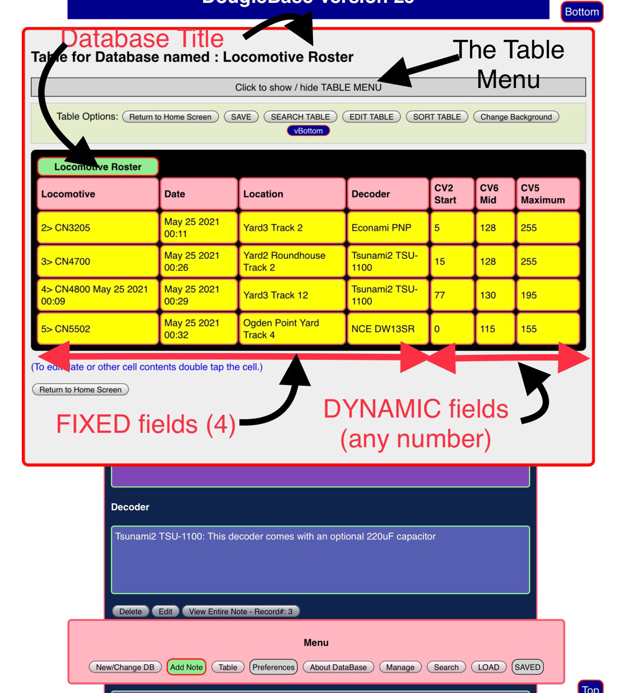

## Creating a Table

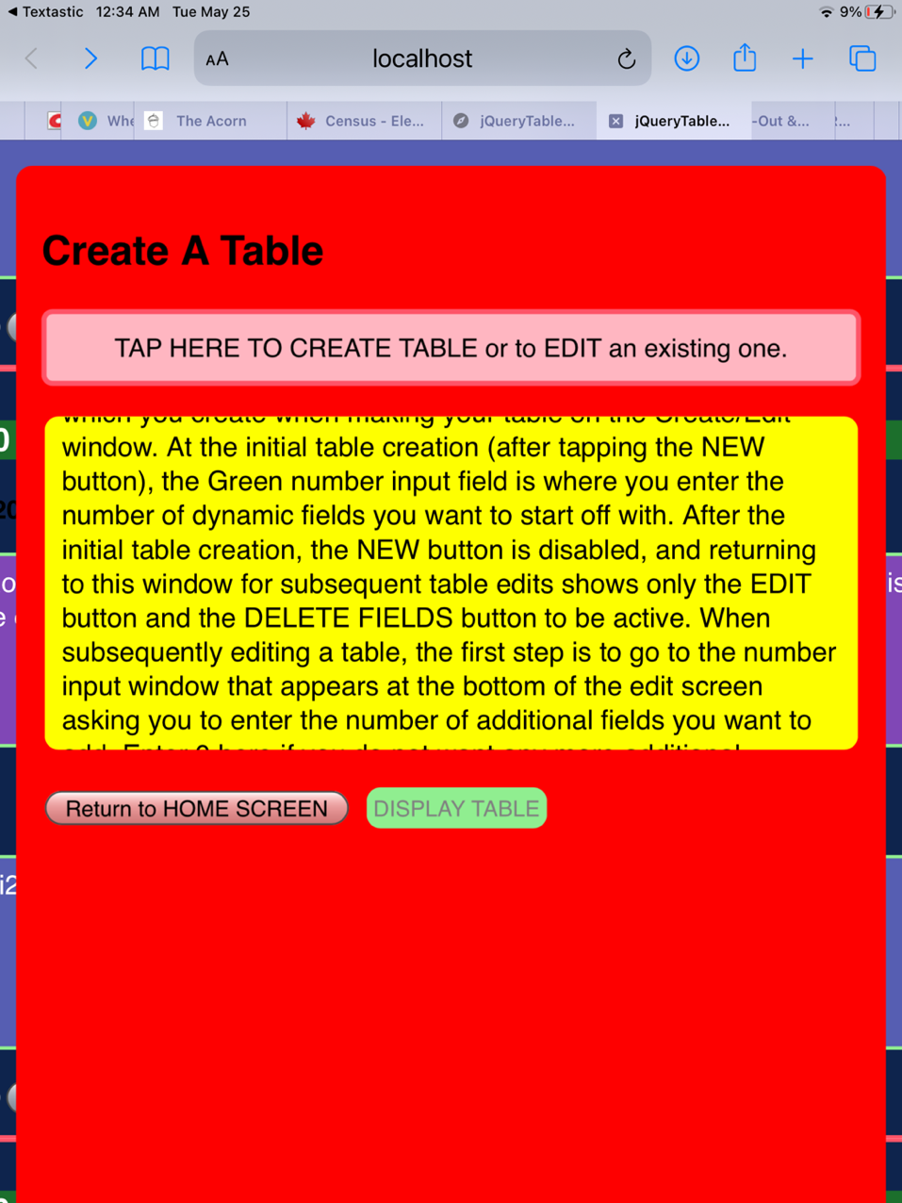Tap the TABLE button in the main menu. This brings up the Table sub menu screen from which you create a new table. The DISPLAY Table button will currently be disabled as a table does not exist yet. In the Create A Table window, tap the ‘Create New OR EDIT an existing table’ direction bar.

The next screen shows the NEW table button highlighted in attention mode…green with red border. The EDIT table and DELETE FIELD buttons are currently disabled, as a table does not exist yet.

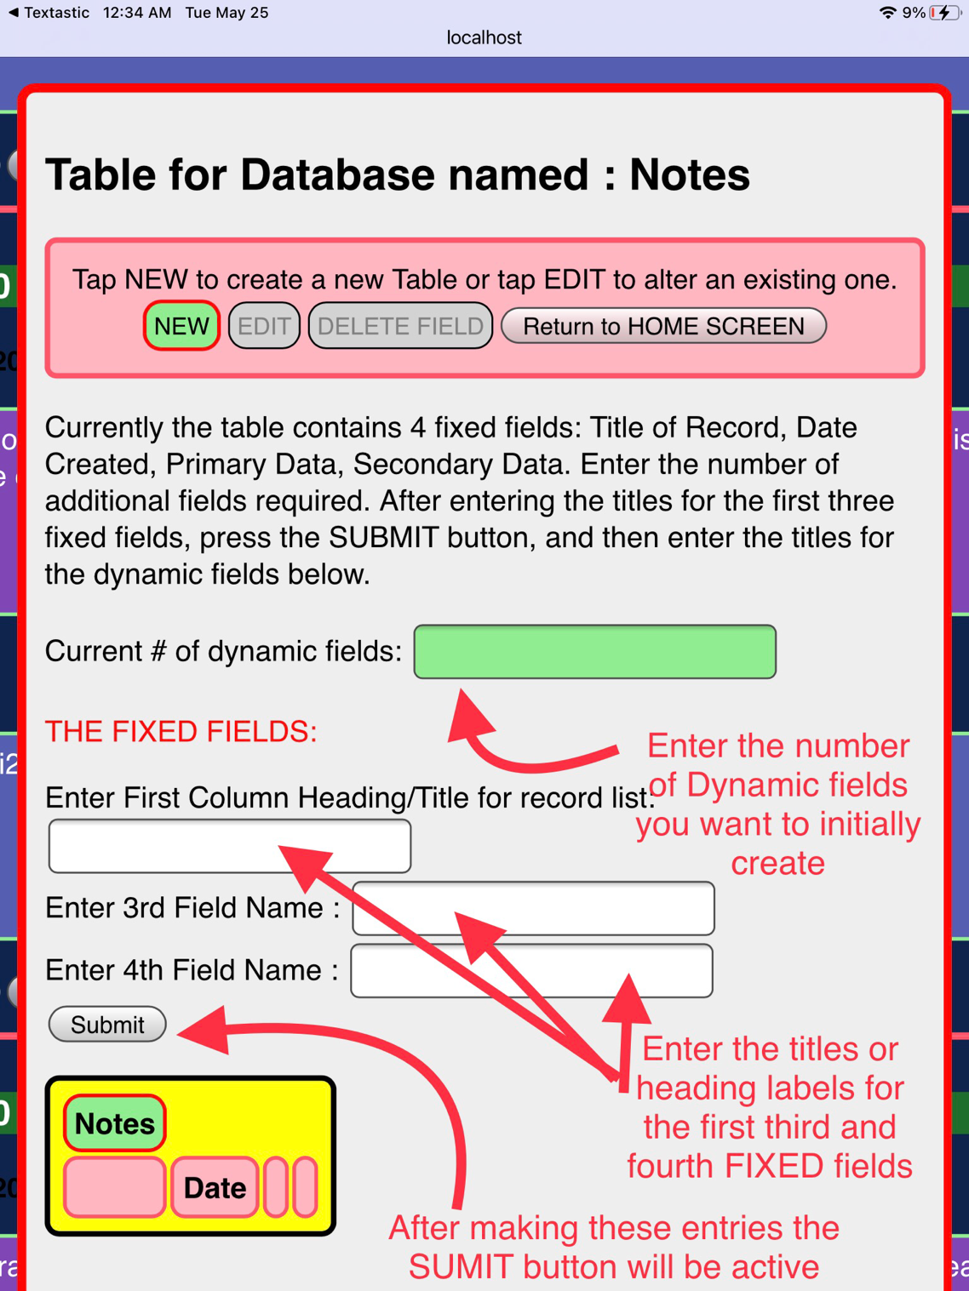

The database name is temporarily called NOTES. This will be replaced by the name of the database you are creating the table for after you have made some obligatory entries. Remember that DougieBase sees the table as containing 4 FIXED fields, and the rest DYNAMIC fields of the database author’s creation. When you first create a table you start with the number of dynamic fields you know you need at the moment. You can change this at a later time, as DougieBase allows you to fully edit dynamic fields, including adding more fields, or deleting pre-existing ones. Only the FIXED fields are permanent in that you can not add Fixed fields or remove them. However the text content of all fields, FIXED and DYNAMIC including the DATE field can be edited at any time.

Start by entering the number of Dynamic fields into the green input element that you currently wish to create. Then enter the headings (labels or titles) of the first, third, and fourth FIXED fields. DougieBase has already allocated the second FIXED field for the DATE, which is automatically generated. When you complete this task, the SUBMIT button is enabled to ‘Attention’ mode. Tap SUBMIT.

For this demonstration we will create a database which was called Locomotive Roster. We will document all the locomotives on a model railroad. The first title field will be the locomotives road number. DougieBase has already labelled the second FIXED field Date. The heading for the third field, which reflects the data entered in the primary data field in Notes, we will call Location. Model railroaders put electronic devices into their locomotives to control them, so the fourth field we will give the heading Decoder. When you tap the SUBMIT button you will notice the EDIT and DELETE FIELD buttons at thebtop tool bar become enabled. The table icon below the Submit button will now show the FIXED fields headings as you entered them. The SUBMIT button itself is disabled, and three text input elements appearbelow the table icon ready for you to enter the title headings for the three DYNAMIC fields you are creating. Beside eack text entry element is a small green circle with red border(in ‘attention mode’) which you tap to submit the text entry for each dynamic field. When you have finished these entries tap on the pink direction bar below the dynamic field titles to finalize the entries and to move on to the next step.

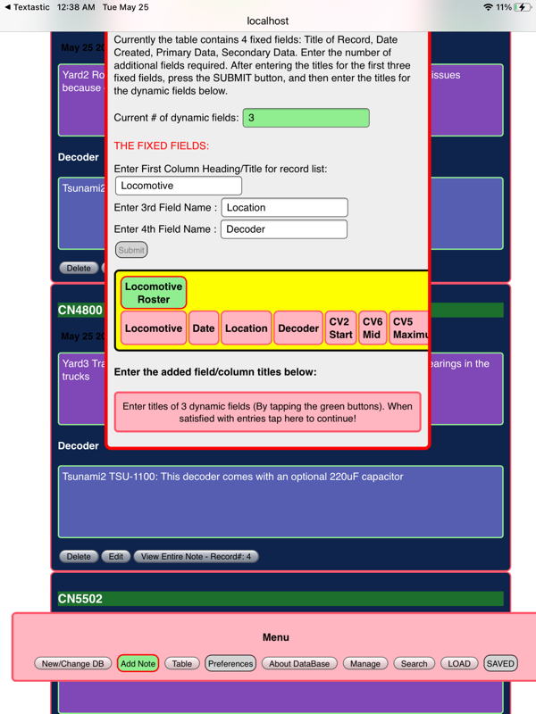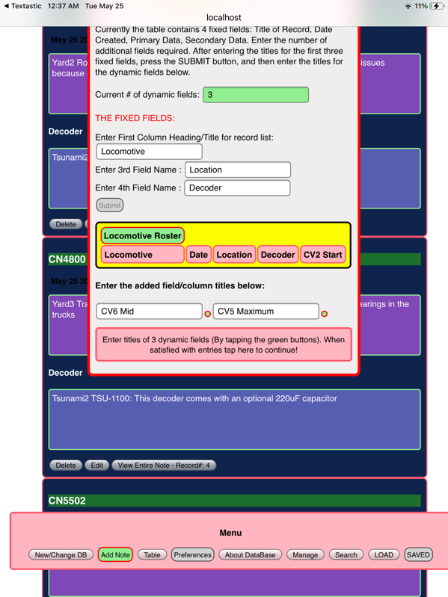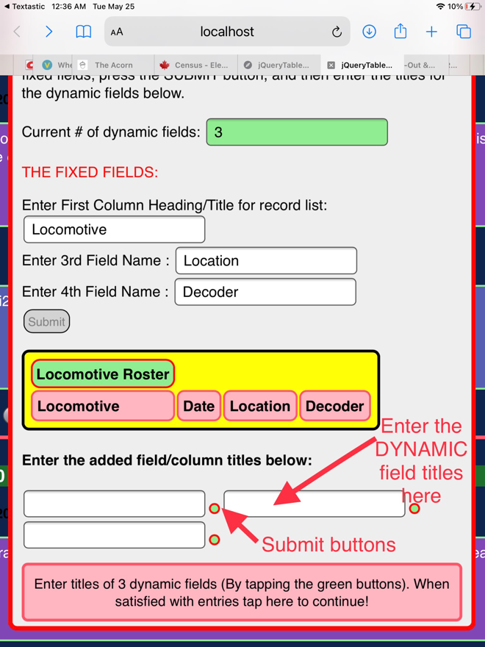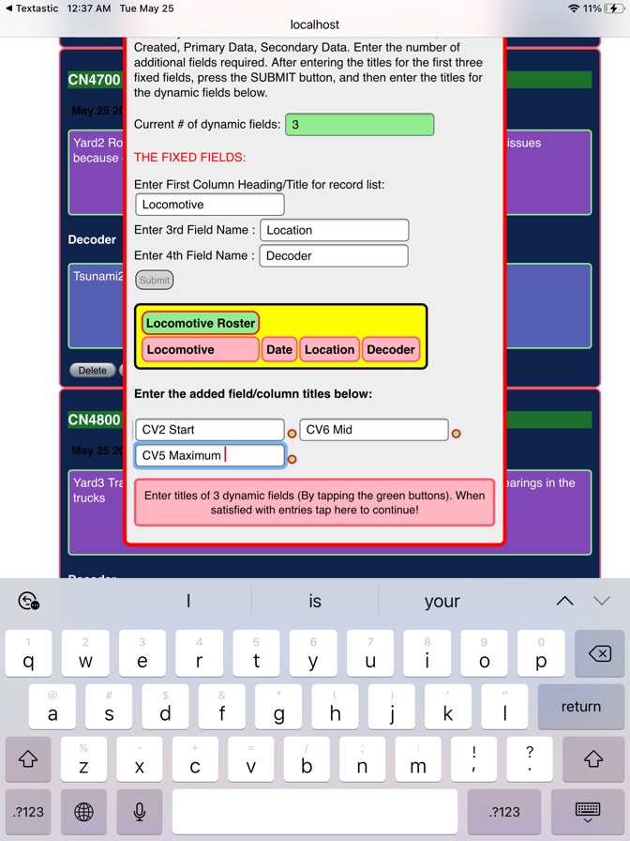Decoders are tuned by setting values in certain CVs or computer variables so our model railroader is going to keep track of his settings using his database. So the first three DYNAMIC field headings are CVs. He his tracking CV2 CV5 and CV6 so these are the headings he has entered for the three dynamic fields.

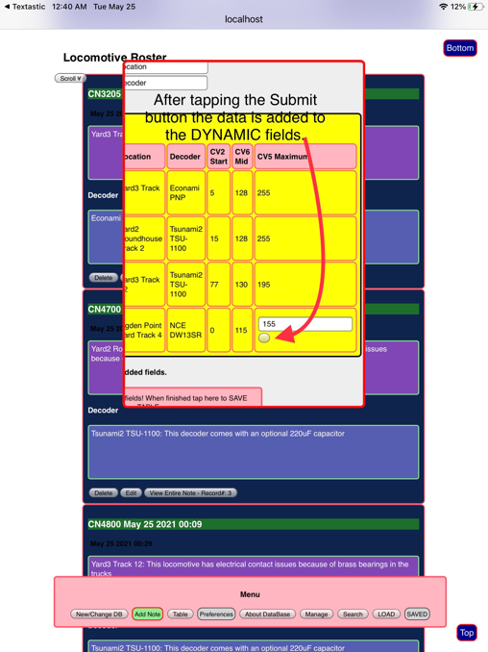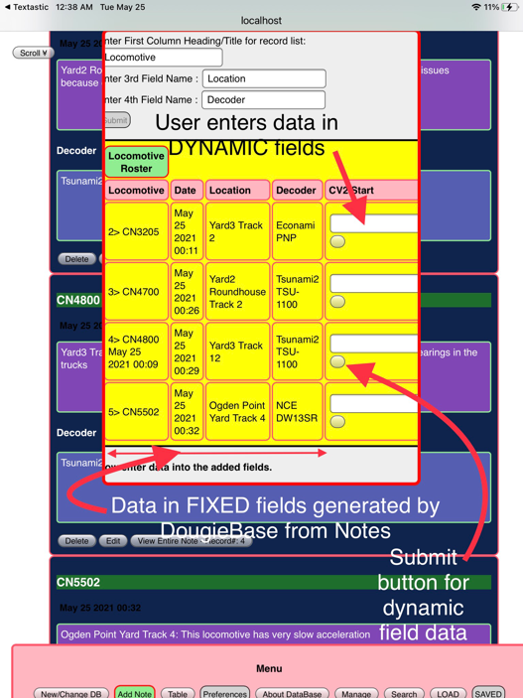Notice that as each entry is made the title appears in the header of the Table icon. After finishing this task tap on the pink direction bar below the dynamic field entries to continue.

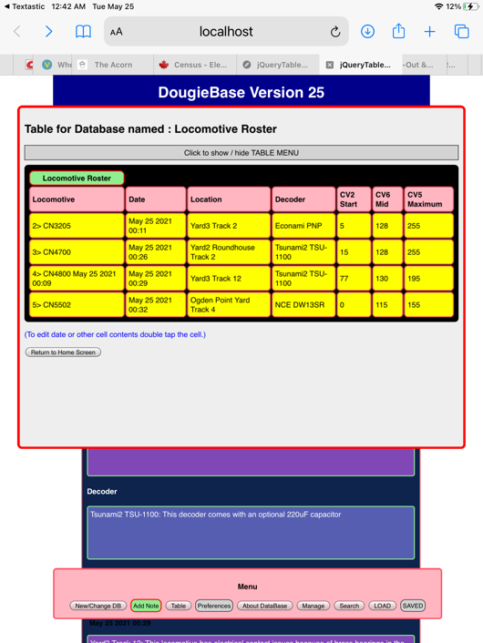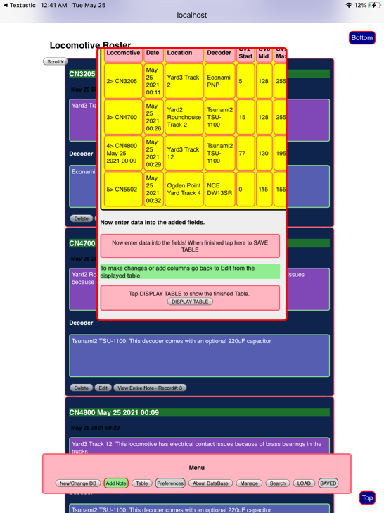 DougieBase now starts to generate the table, using data from Notes for the FIXED fields, and the data you enter into the DYNAMIC fields.

## Editing a Table .. changing the layout

Now that a table has been generated, you can edit the table. Tapping TABLE in the main menu takes you to the Create Table window and from here tapping the ‘Create OR EDIT a table’ direction bar takes you to the Table EDIT window. This window will be familiar but the NEW button is now disabled and the EDIT button is enabled in ‘Attention’ mode. Tapping EDIT brings up the table edit screen shown below:

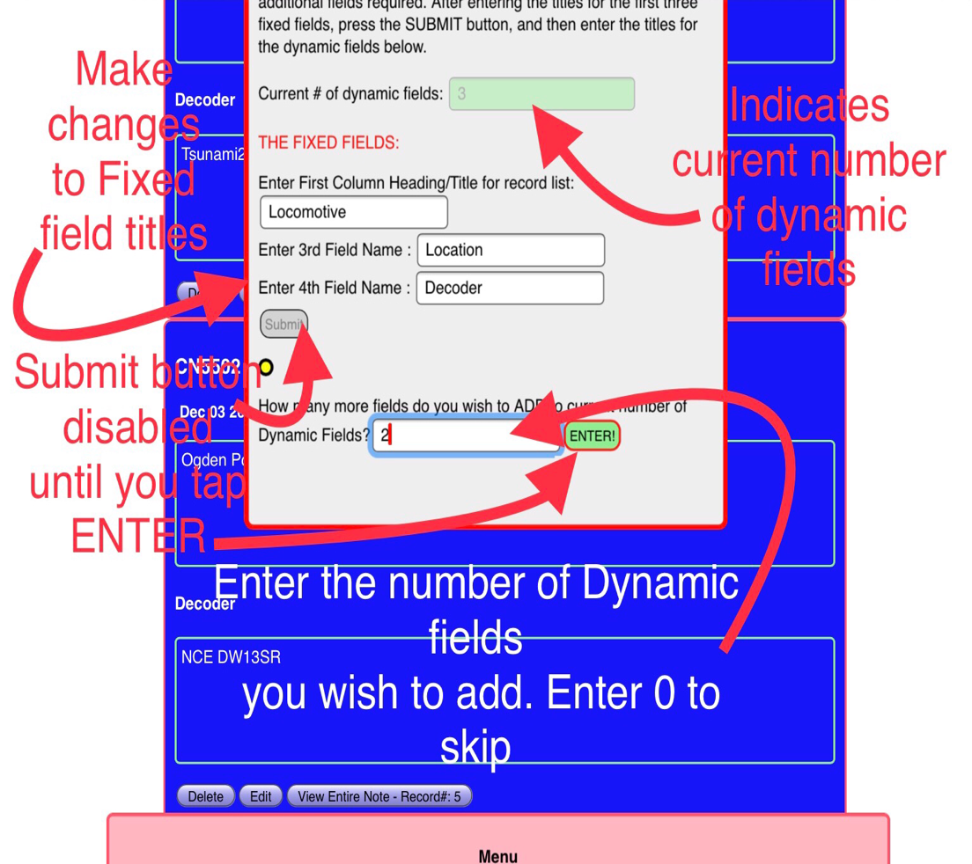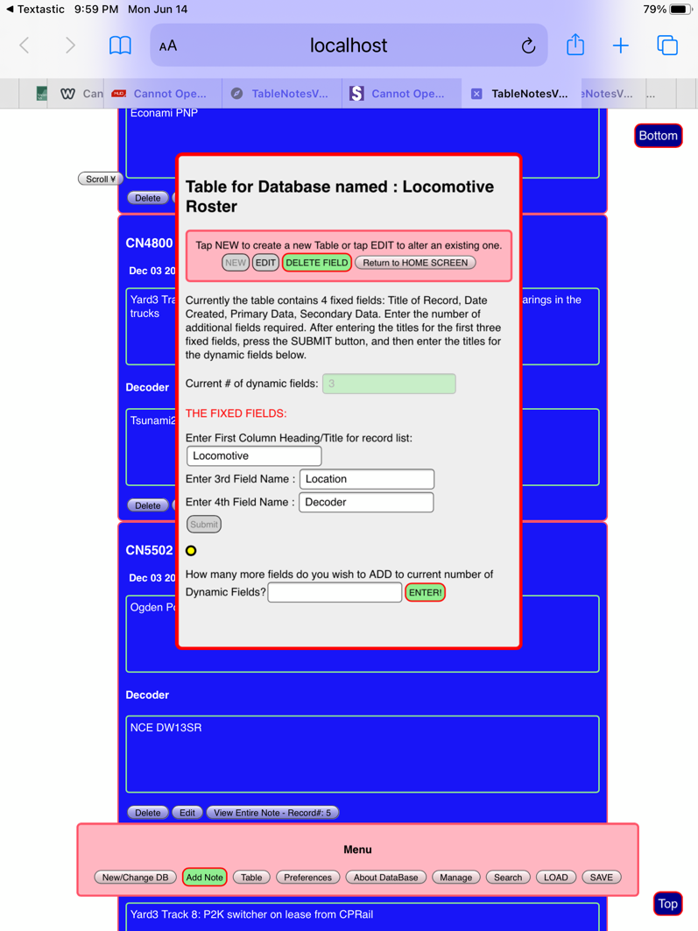

#### Adding a Field

The EDIT button is now greyed out and your attention is drawn to the ENTER button at the bottom of the screen Here you enter the number of Dynamic fields you wish to add.All previous entries in the header fields of the FIXED fields are shown, and the current number of dynamic fields are indicated in the greyed out green bar above. When you enter the number of new fields desired the number in the green bar will increase accordingly, reflecting the new number of dynamic fields. If you only wanted to edit the title headings of the FIXED fields and did not want to add more fields just enter a 0 into the Add fields input element.. when you tap the ENTER button it will grey out and the SUBMIT button will be in ‘attention’ mode indicating to tap it after all your changes are made. This will bring up new input elements for 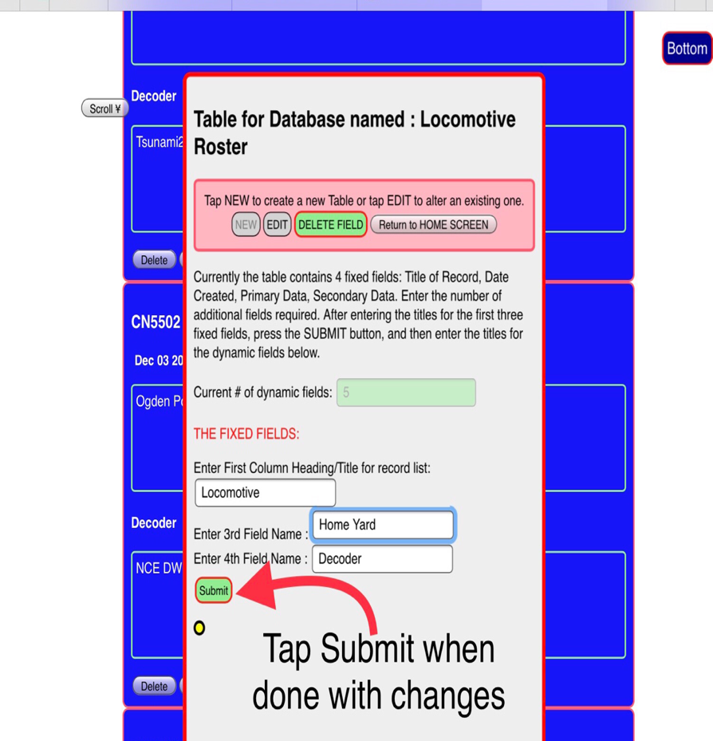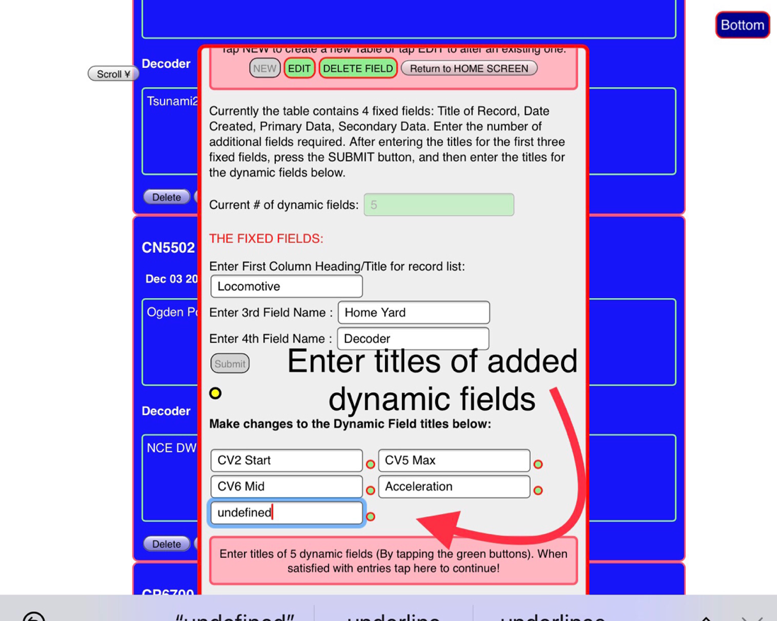entering the headings of the new DYNAMIC fields you created.

The new headers are entered when you tap the small submit buttons beside each input element.Follow the guides and finally tap DISPLAY TABLE to see your new table.

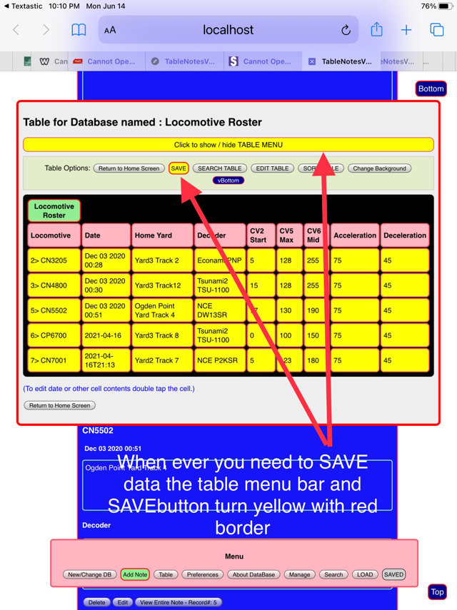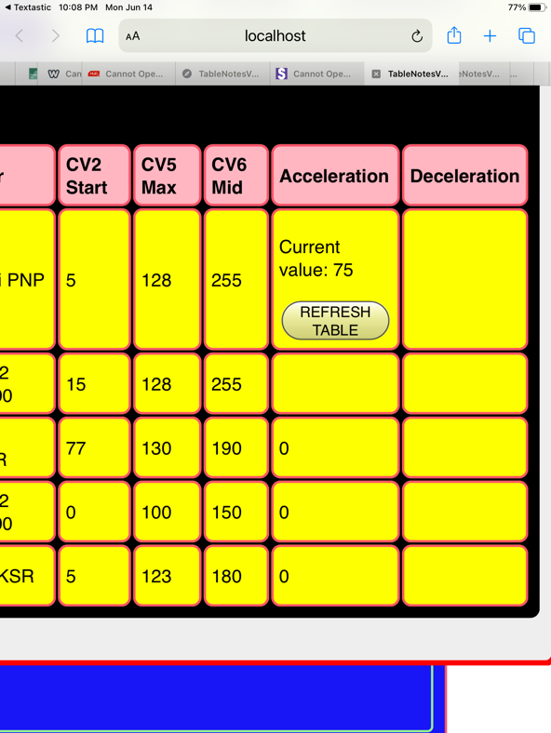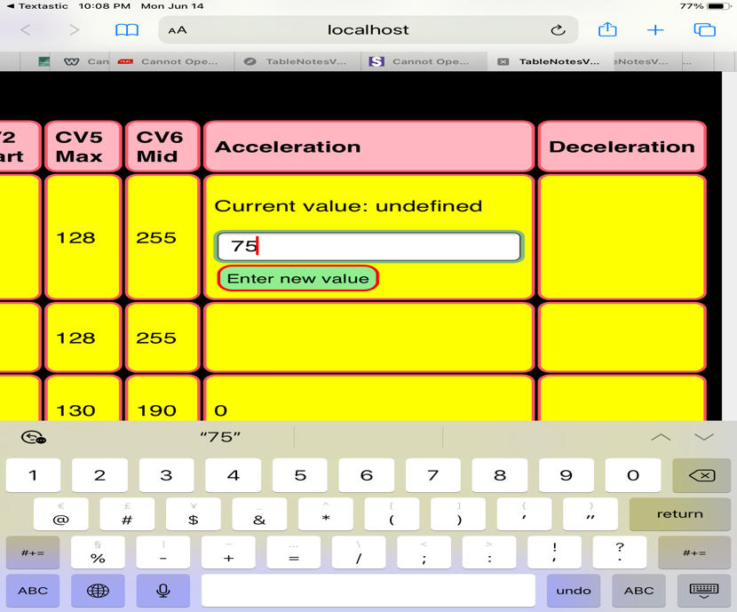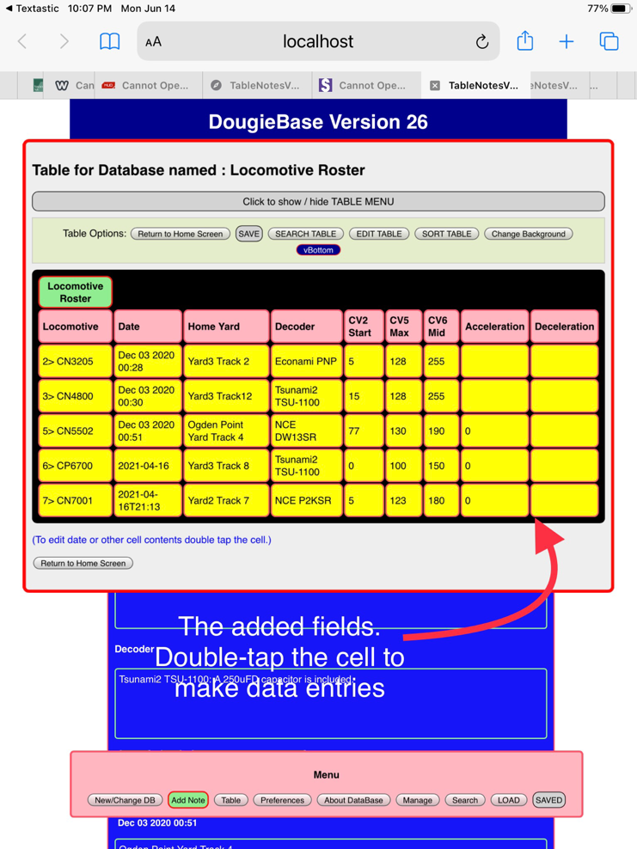**To enter data into the newly created Dynamic fields** just double-tap the appropriate table cell. Clear the input field, enter the new data, tap enter, then REFRESH to see the data entry in the cell.

Whenever you enter new data, it is necessary to save your work, and DougieBase reminds you to do this by highlighting the table menu bar (in case the menu buttons are hidden), and also highlights the SAVE button in yellow with red border indicating .. do this! If you do not SAVE, the data entries will be lost after returning to the notes section.

The next most used function in DougieBase is deleting a field.

#### Deleting a field

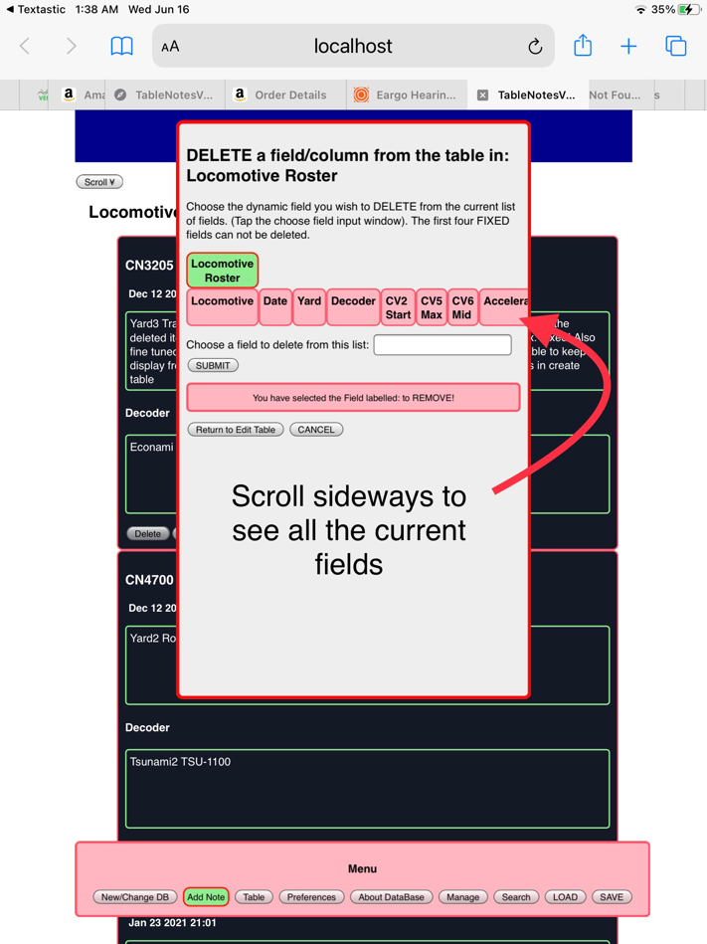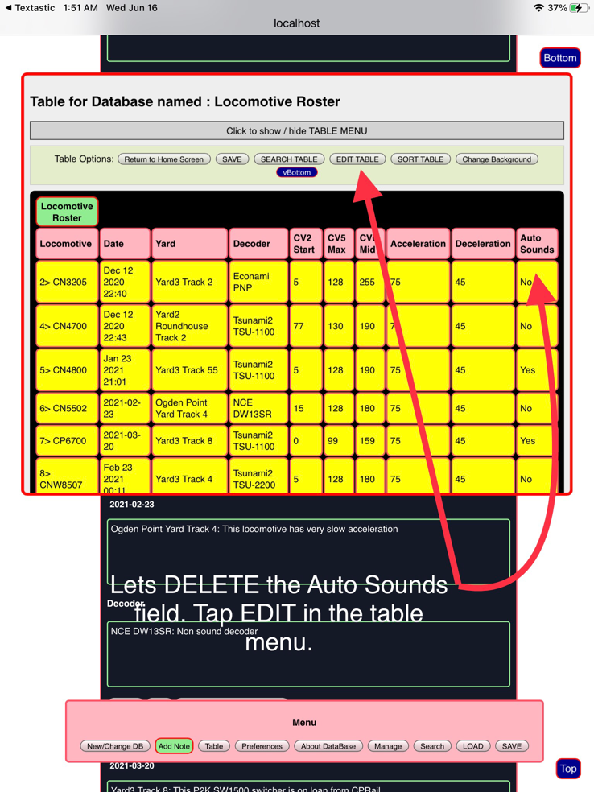Another option available from the edit table window is DELETE FIELD. Tapping the DELETE field button brings up the delete field options screen.

All the field headings are shown, including the FIXED fields. Only Dynamic fields can be deleted. Scroll the field heading to the right to see the rest of the fields. To choose the desired field tap on the ‘Chose field to DELETE input element. This brings up the item select picker 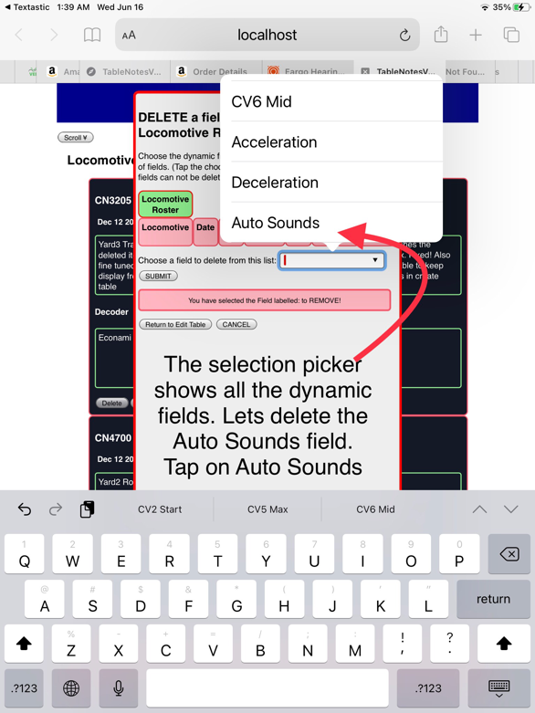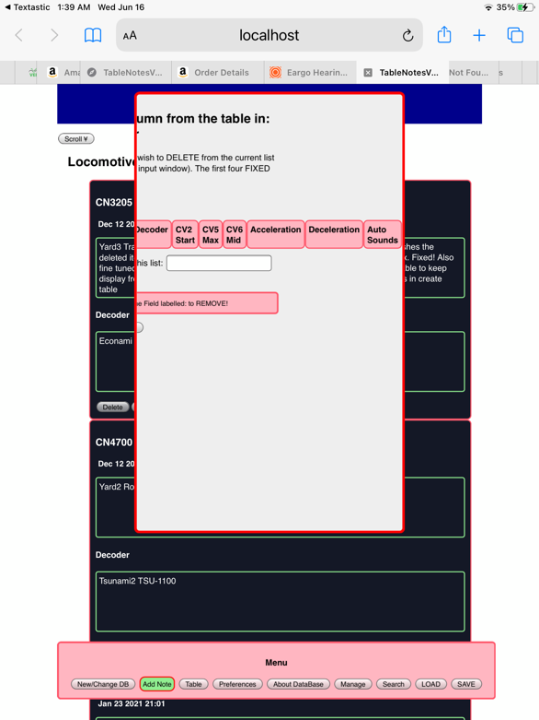which only list the Dynamic fields. Tap on the field name to select.

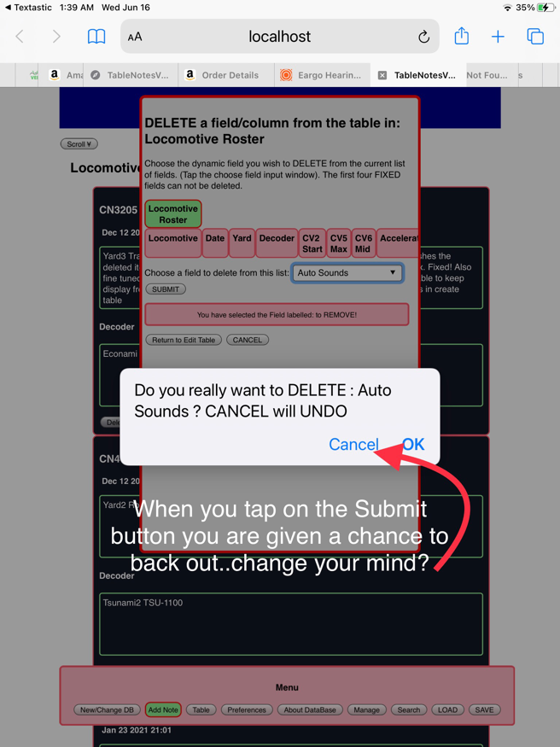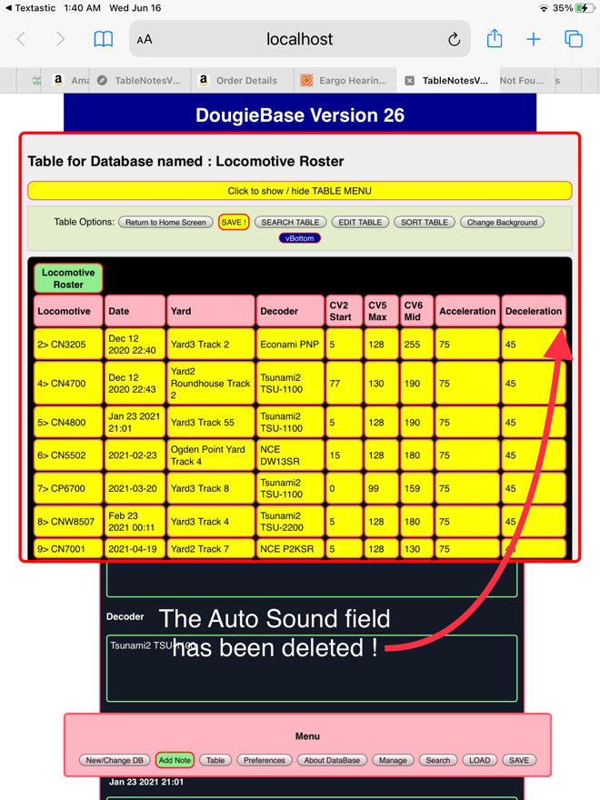You are given an opportunity to change your mind, but be sure here, as once you tap ‘OK’ the field is deleted! Don’t forget to SAVE!

#### Editing the Date

In the table the DATE can be changed by double-tapping the appropriate table cell containing the date you wish to edit. DougieBase automatically generates the date (month-day-year-time) at the time each record is submitted. At any time you can change this date. The browser’s native date picking tool appears when you tap twice on the date cell. You can choose to include the time stamp as well as the day and month. Set this in Preferences. When the new date is SAVED in the table it is also SAVED in the notes section…and vice versa.

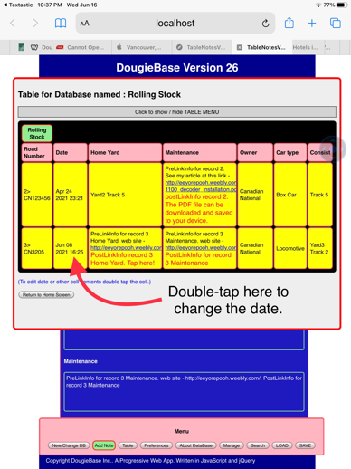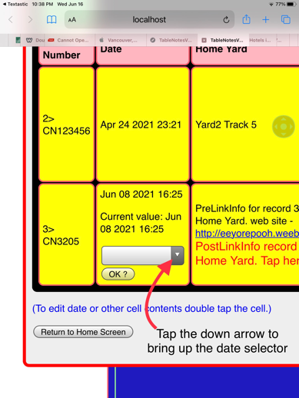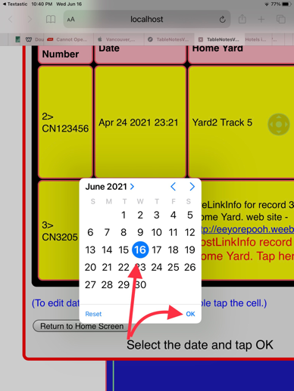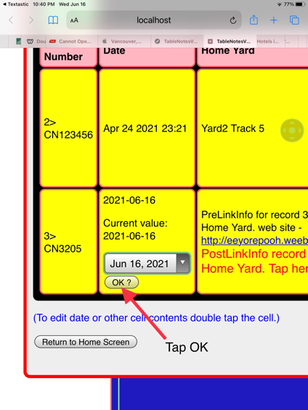Here are the steps:

1. **2. 3. 4.**

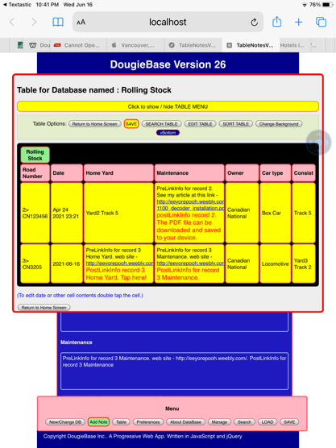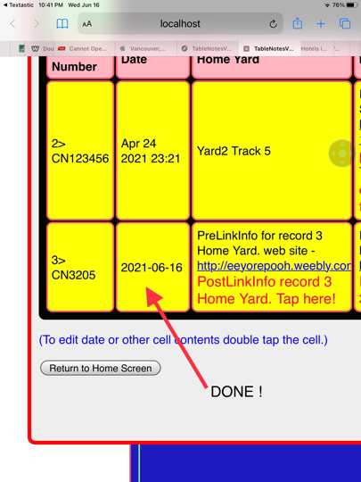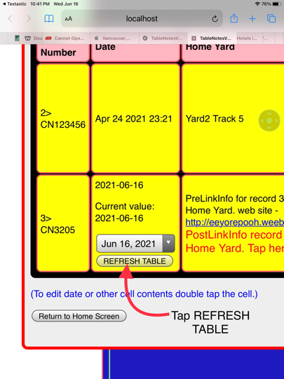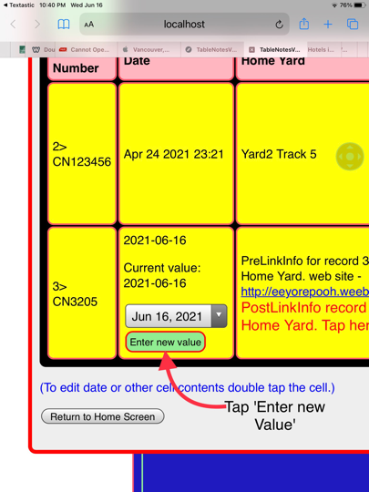**5. 6. 7. 8.**

## Search

#### Overview

DougieBase has a simple search engine that allows searching for and high-lighting a specific record. The search can only be performed referencing the first title field. The title or name (taken from the first field) of the targeted record is entered into the search title input element. The search can be Case Sensitive OR NOT. This setting is also chosen in Preferences. It should be noted that ‘spaces’ count as a search character, so that for example if you entered a title as two words separated by a space but don’t include the space in your search input DougieBase returns record NOT FOUND. If you entered a space at the end of the record title when you created the record, but don’t include this space at the end of your search input, you also get ‘Record not found’ as the result.

When DougieBase finds the record in the table it lists the results of ‘record found’ below the direction bar. All successful record searches are listed here until such times as you clear the list by tapping the Clear Record List button.

If you double-tap the name of a Found Record in the list you are taken to the ‘View Complete Record’ screen allowing you to see all the associated notes or data entries for this record.

After entering the name of the desired record to Search for, and tapping the ‘Find Record’ button, and the record name appears in the Found Record List, indicating a successful search, you can now tap the ‘Highlight in Table’ button to see the record highlighted and emphasized in bold lettering in the displayed table.

If you are in the ‘View Complete Note’ of the Notes section, and you tap the Search button in the main menu, the record title name of the record you are currently viewing will be automatically entered into the search input element in the search screen.

To facilitate data entry the Clear Input data button will empty the search input element of pre-existing text, and the ‘Clear Found Records List’ button will empty the ‘Found Records’ list.

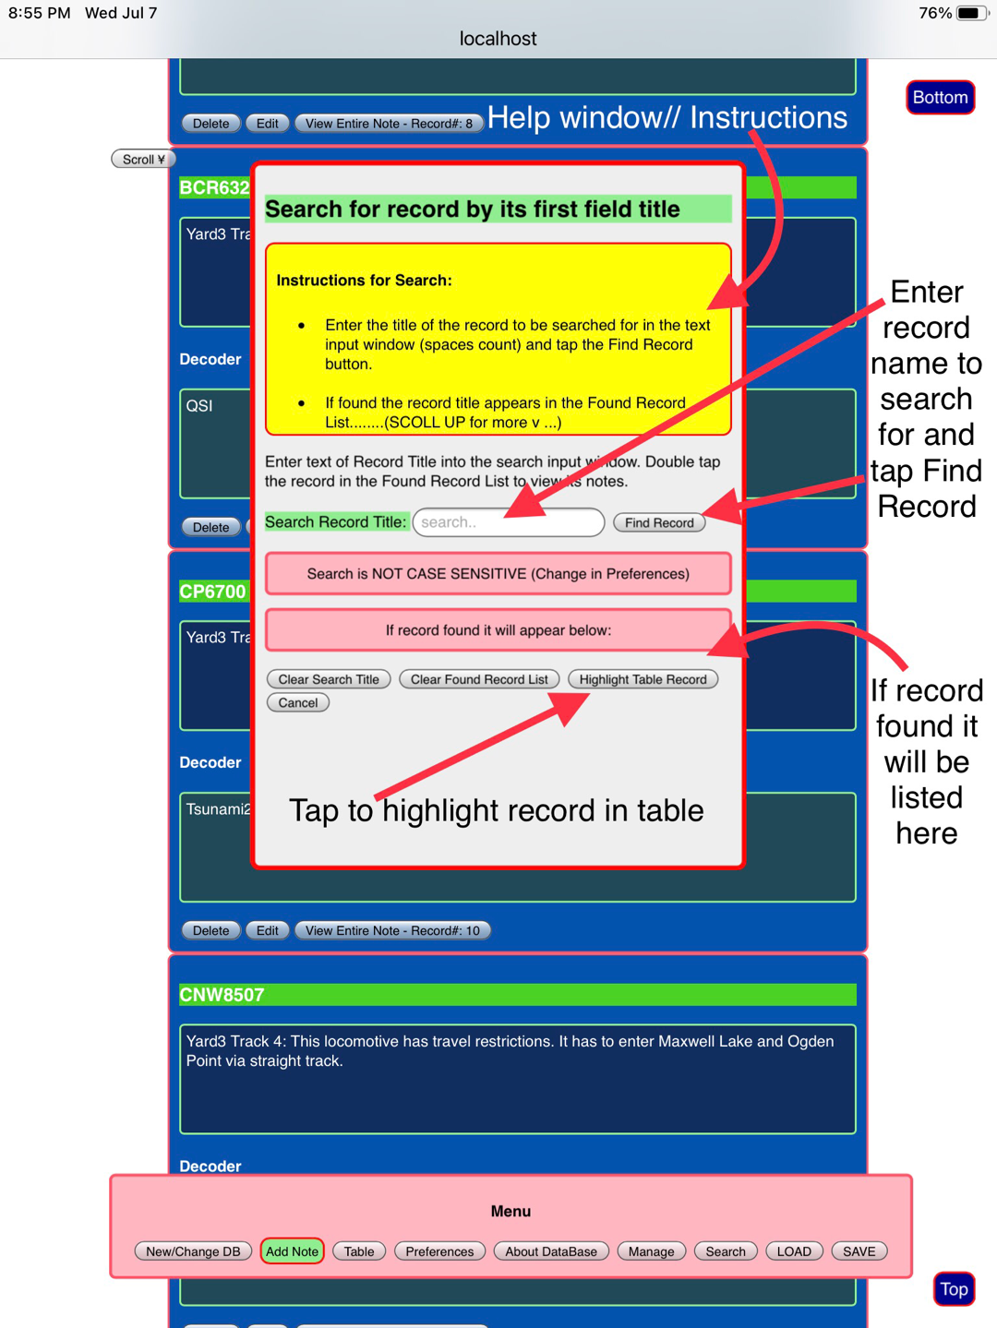Tapping the SEARCH button brings up the Search window:

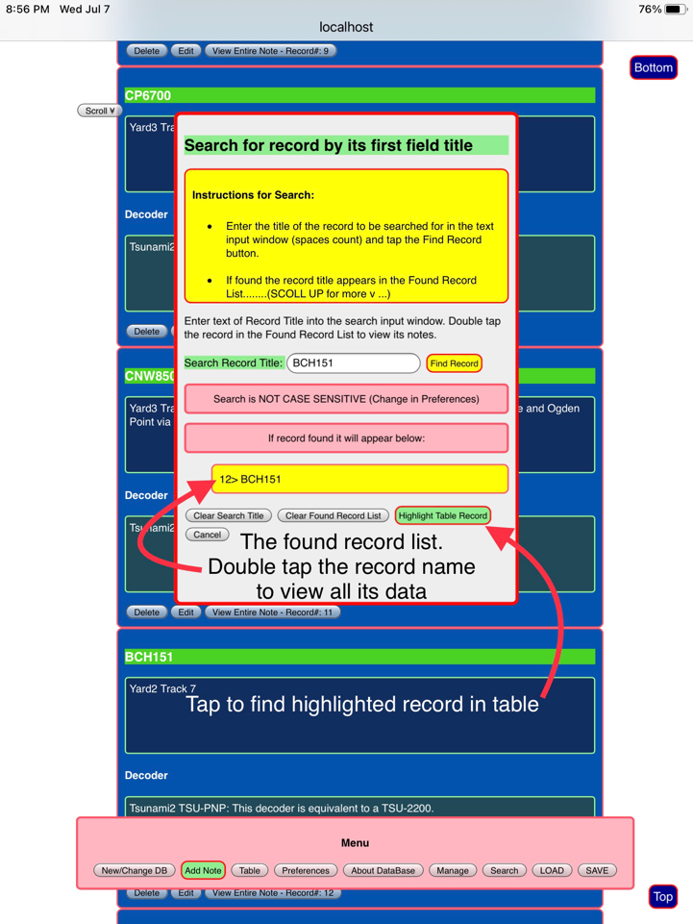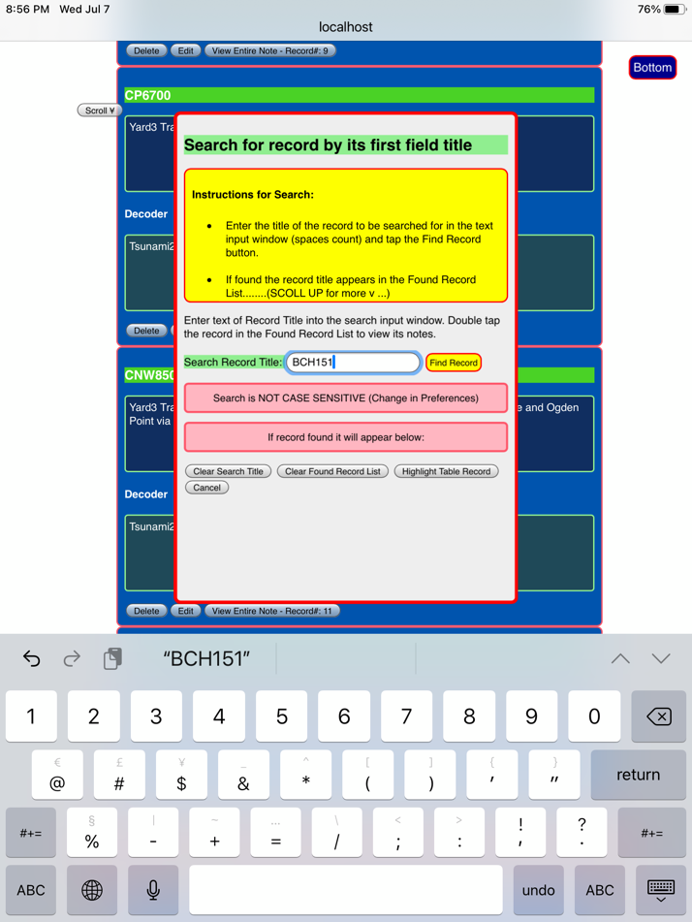After entering record title to be searched for tap Find Record.

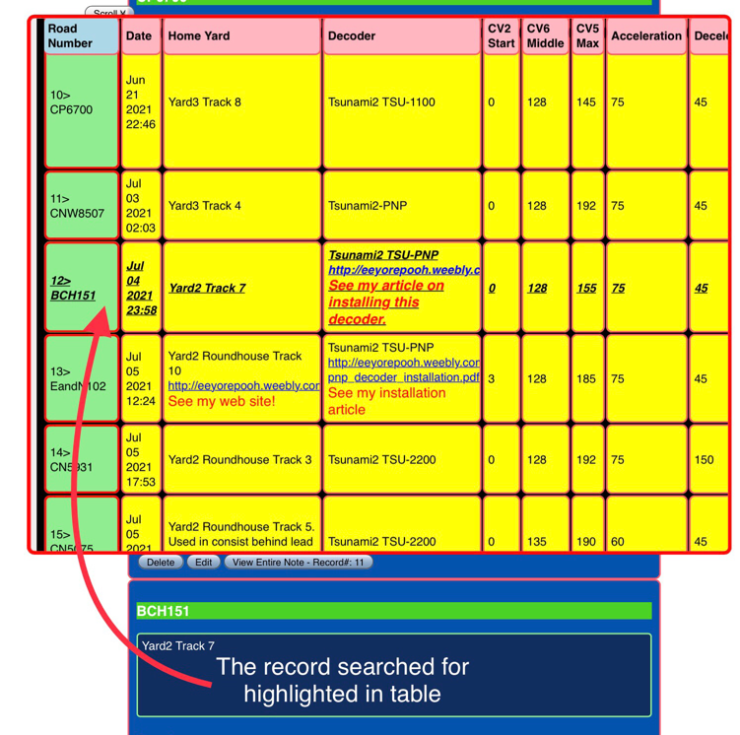**A record highlighted in table:**

The highlighted record will automatically scroll into view.

## Sorting recoRds

#### Overview of Record Sort

DougieBase allows sorting of records based on the record title. There are three options for record sorting:

* Alphabetical order
* Reverse order
* Return to order of original or initial entry

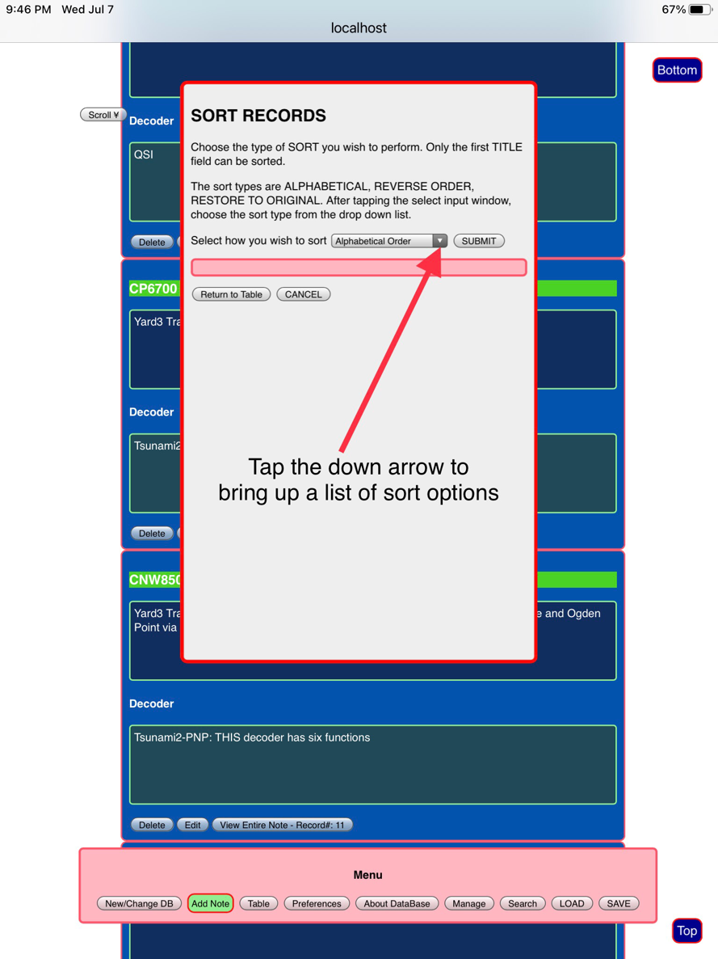Tap the sort button in the Table menu to bring up the Sort window.

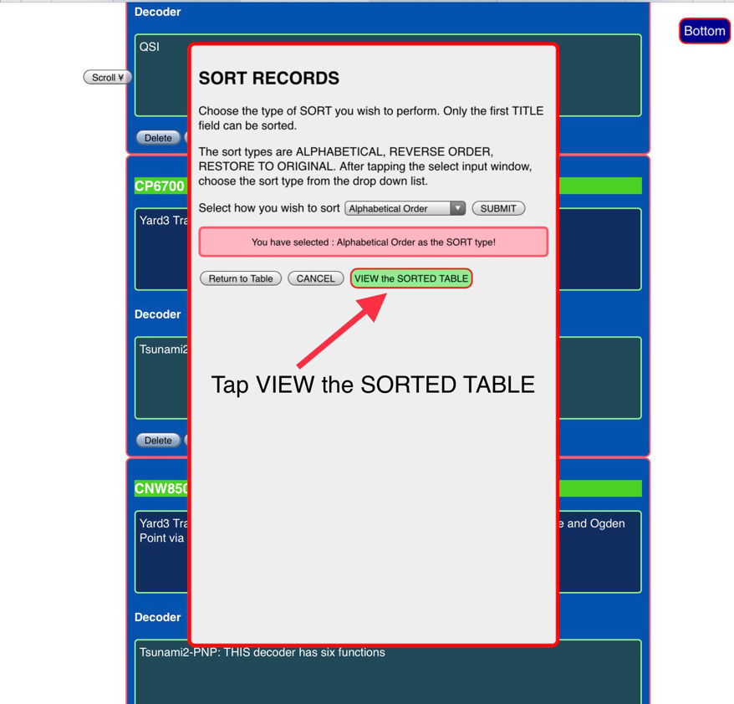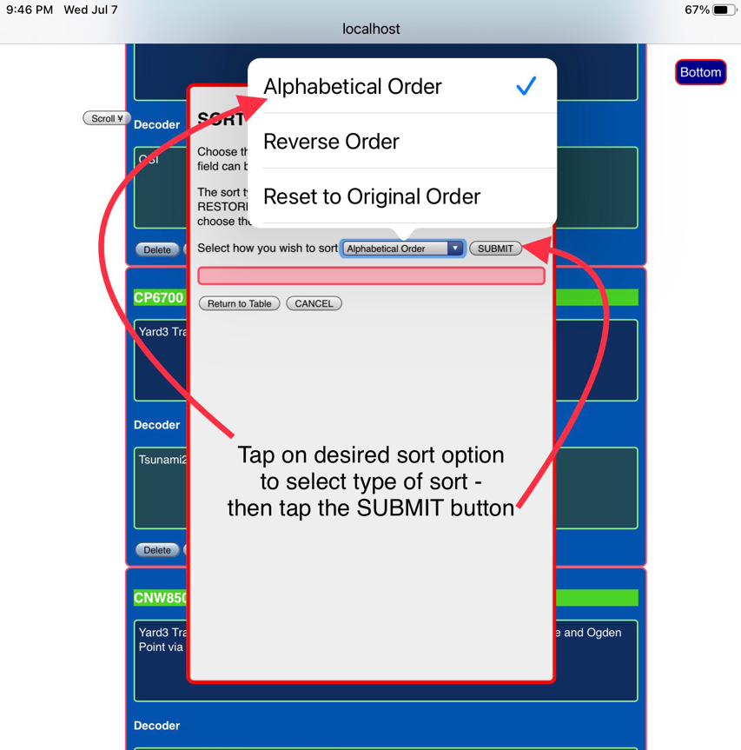Choose the Sort option and then tap ‘VIEW SORTED TABLE’.

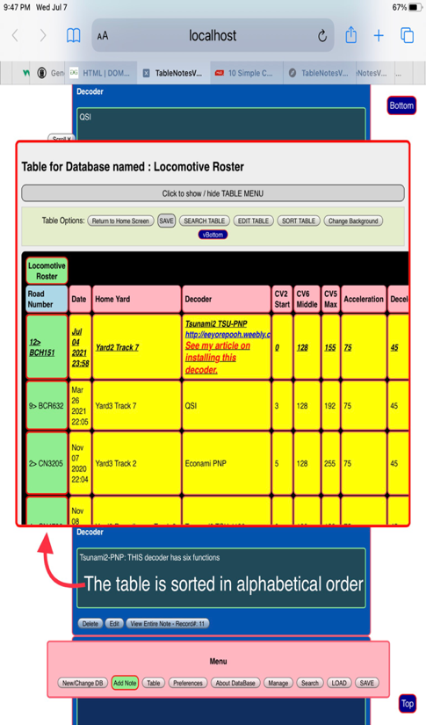The table is sorted in alphabetical order:

## Managing Database filEs

#### Overview

As you create more databases, DougieBase will keep track of all the databases you have in memory.When you tap the Create New or Change Database button you are presented with the list of current databases you have in memory. To manage these files tap the MANAGE button in the main program menu. This brings up the Manage File Names window.

From here you can

* Delete a database
* Clear a database
* Backup a database
* Restore a database

You first need to select the database file you wish to work on. Double tap on the filename in the list. The selected database will be the target of your next actions. If you are restoring a database that had been previously backed up, its name will not appear in the above list, but DougieBase retrieves the database name from the backup data you enter in the Restore Database window. (See RESTORE a database).

#### Delete a database

Choosing to Delete a database from the browser’s me ory has its idiosyncrasies. Tapping the DELETE database button should remove the database name from the list of databases and erase the database from the browser’s storage memory. This works most reliably if you perform a delete action prior to opening the database. If you attempt to delete a database that has just been opened for say a read or write action, the browser locks the database preventing its deletion, and you have to wait for the browser to release the database after a timeout period. In such an event DougieBase gives you an error message alert indicating the database failed to delete. In this event wait and try again later.

#### Clear database

This option is not currently supported in DougieBase

## Backup And Restore

#### Backup and Restore are two of the most important functions in DougieBase

One downside of a PWA running in web browsers via javascript, is that the conventional file handling of data files in terms of saving to external file systems or storage drives is somewhat lacking without further support via other coding languages.

DougieBase gets around this backup and restore problem simply by using iOS copy and paste actions.

#### Backup

To backup a database file use the Manage pane. In the Manage files window you see a list of all the databases DougieBase has currently open. Double tap on the file name to SELECT the database you wish to BACKUP. After you have selected the file you want to backup, tap the Backup button. This opens the Backup window. Here you simply do a Copy/Paste action to put the data into the iOS Clipboard and from here you Paste the backup data into any external storage file you wish to use to store your backups. You can use a file in the cloud (Dropbox, Box, One Note, etc.) or use a note keeping app such as Apple Notes, Bear, etc. Of course you can paste as many times as you like so best to use both the cloud and a native app.

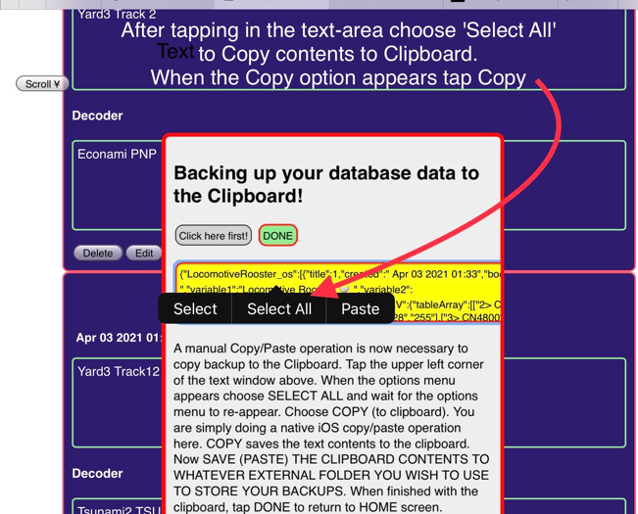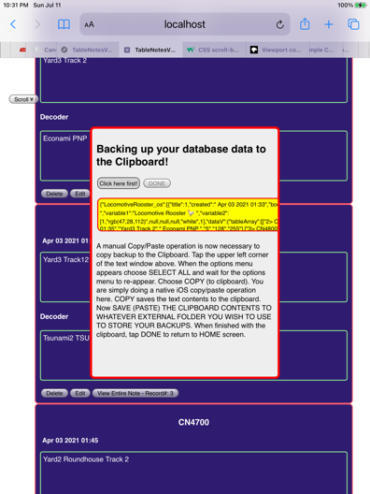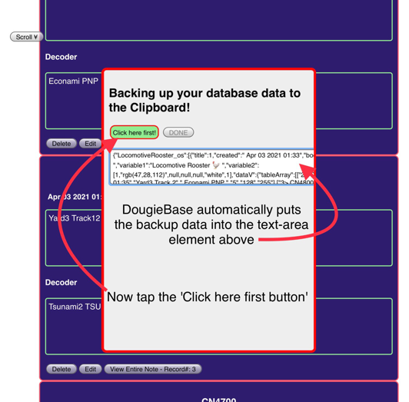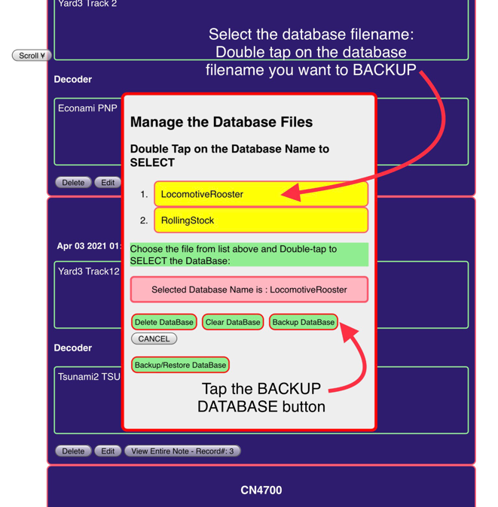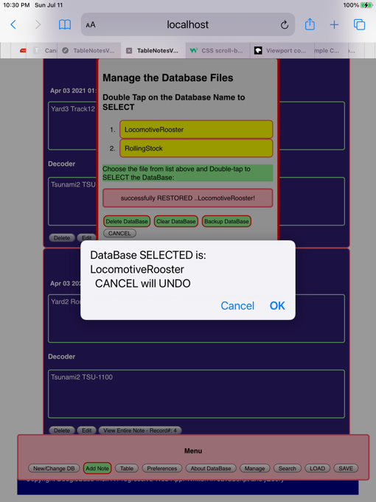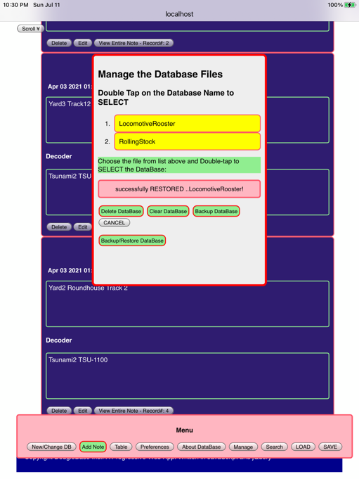**Select the database file to backup**

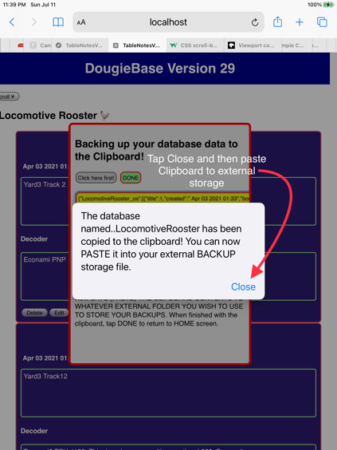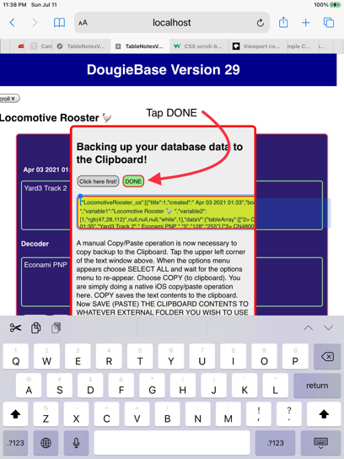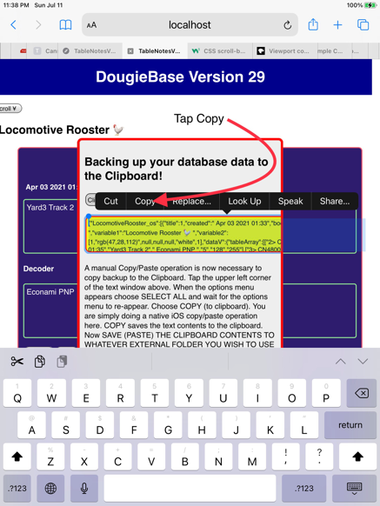**Start the Copy/Paste action**

## Restore a database from a backup file

The Restore function can be accessed from the Current Database files screen or from the Manage window. To restore a database use Copy Paste from the file storage you have chosen to use for keeping your backups. Select and ‘Copy’ the backup data from your storage file. Be sure the data begins with {“. That is a curly bracket followed by a double quote. DougieBase sends an error message if you paste data without this format. The backup file ends with }]}.

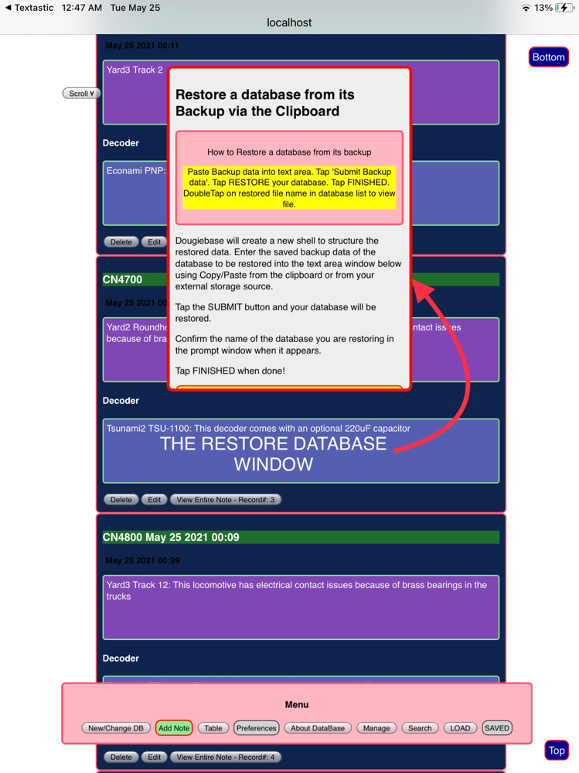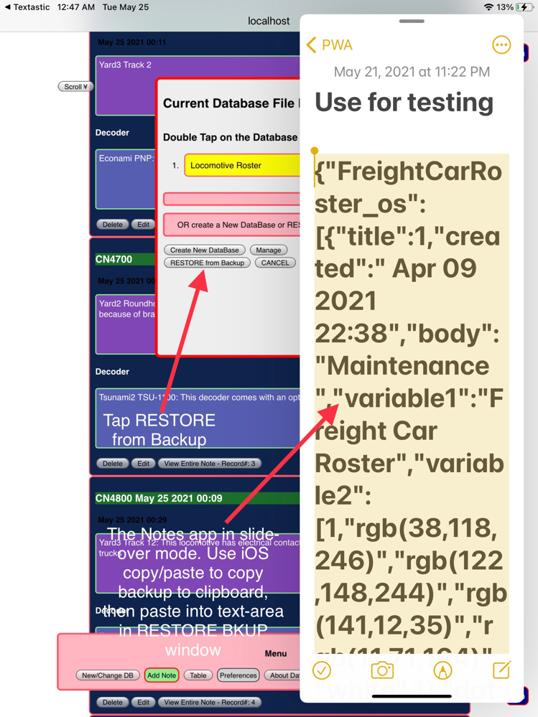

When you tap on the data entry text-area element, its border turns blue, paste the data into the text-area and tap the green SUBMIT Backup button. This button will now turn yellow, and the ‘Click here to RESTORE database’ button turns green with red border indicating you tap this button next. This brings up a confirmation prompt with the restored database’s title. Tap OK to restore, or Cancel. Cancel returns you to the home screen without restoring this database.

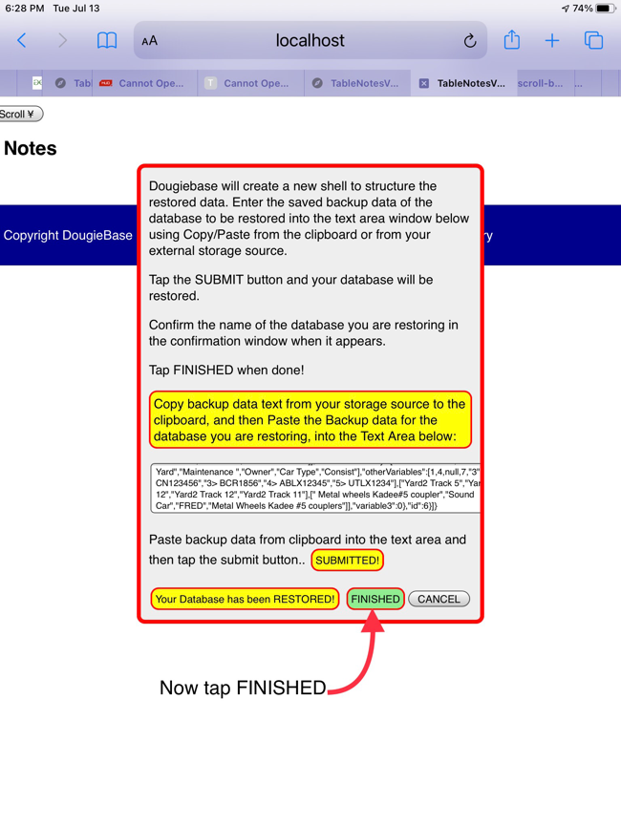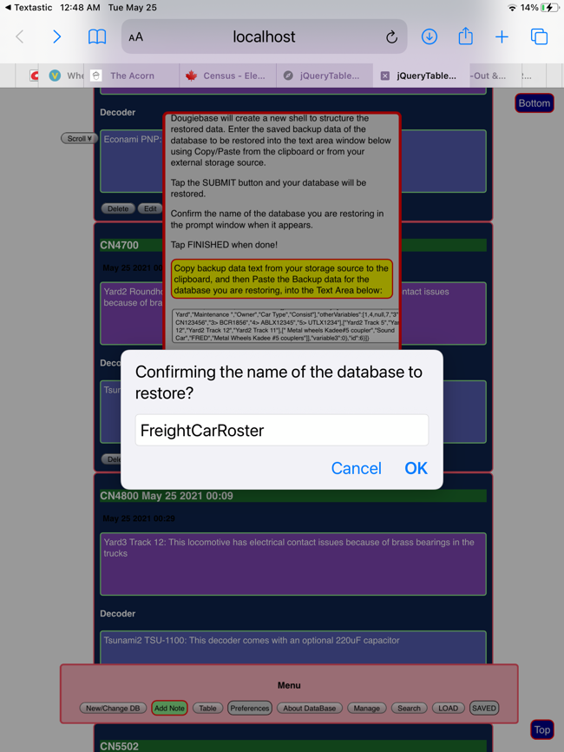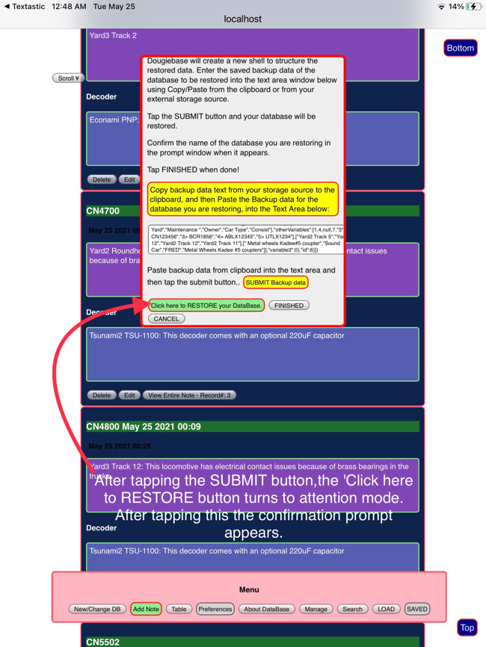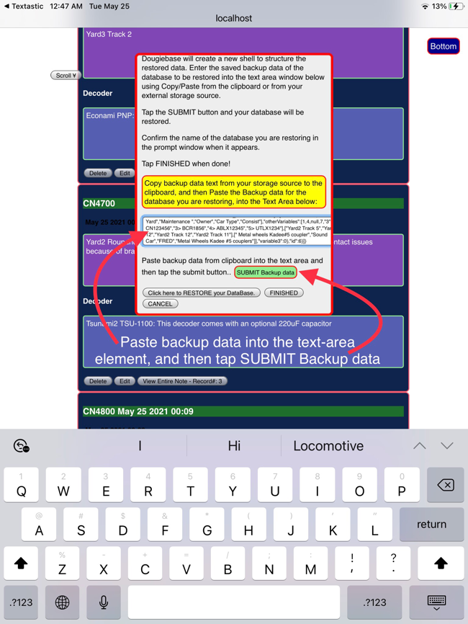

Now tap ‘FINISHED’ and your database is restored.

Its filename now appears in the Current Database File Names list, and a message confirming successful restoration of the backed up database appears in the information bar. To view the restored database double-tap its filename in the list to load it into DougieBase.

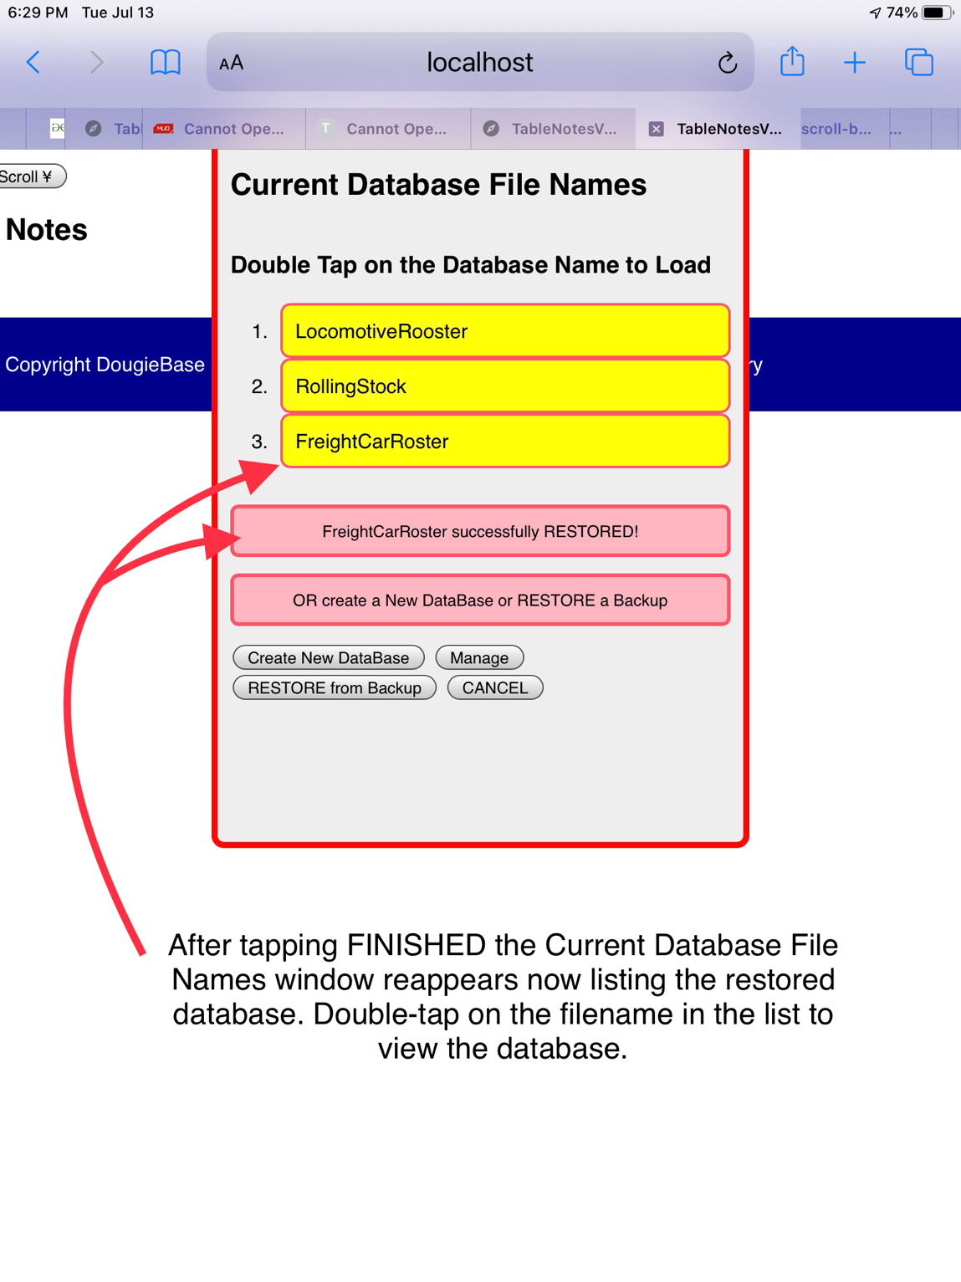

## Using Links (urls) in DOUGIEBASE

DougieBase is designed to handle ‘active’ links. By active link is meant that clicking on the link takes you to it’s intended target.If you enter a link or URL into a data cell in the table, this link will be active and tapping or clicking on it will take you directly to its web page or target site. Links or URL addresses entered in the data sections of DougieBase Notes, will not be active until DougieBase generates the table for your database. At this time the links entered in the two data fields of notes become active in the fixed fields of the table. Any links entered into the dynamic fields of the table are automatically active.

There is an option in Preferences to allow ‘Link Labels’. By this is meant that the actual link will be replaced by a more descriptive ‘label’ that more accurately describes the purpose of the link, and that when the active descriptive text is clicked on takes you to the links’ target. This allows for less clutter in the table cells, and at the same time providing the user with information about the link. This feature can be toggled on and off in Preferences.

DougieBase uses special formatting characters both in the table cells and in the data entry sections of DougieBase notes to generate these informative labels. The link is parsed out of the text entry. DougieBase sees the data entry as Pre-link text and Post-link text. All the text entered including the link appears in the notes section as entered. In the table, DougieBase discards data text entered after a colon in both the Pre-link and Post-link segments, using only the text entered before the colon to show in the table’s data cell. If the ‘Use link labels’ option is switched ON in Preferences, DougieBase uses the Post-link statement as the active text for the link label. The Pre-link text (prior to a colon) is also included in the table’s data cell. If there is no Post-link text entered, then DougieBase uses the Pre-link text as the link label. This is all generated by DougieBase when creating the table and is transparent to the user. Post-link data in the table always has a red font.

#### Pre-link and Post-link data entry

#### Use Link Labels is switched ON in preferences

## About database

This panel allows you to access some internal information about your database including number of records, has a Table been created ?, etc. From here you can also access the documentation manual, which is stored online.

## Miscellaneous comments

* The scroll feature in Table is designed to maintain the field headings (column titles) and the record titles intact as the records are scrolled. This facilitates keeping track of what the columns and rows of data cells are titled, particularly useful in a larger database containing many records. Some people find this to be a dizzying distraction and so the feature can be disabled in Preferences. Tap the ‘Disable Scroll Table’ button.
* Some buttons in preferences pertaining to table settings are disabled until a table has been created.
* If the database is large, the copy/paste process when backing-up or restoring a database can be a bit slow. Wait for the copy/paste iOS menu bar to appear, indicating iOS is ready for the paste action.
* The database is currently limited to 100 records per database.
* DougieBase is a PWA app and as such is dependent on the integrity of the web browser’s memory. Some web browsers will force clear the memory cache after its data capacity is reached, or a crash of the computer could clear a browser’s memory cache. For this reason it is a good idea to frequently back-up your database’s data so it can be restored in case of any unexpected eventuality. (See Backup and Restore page 43).
* (Internal note) A copy of this file is stored in One Drive (July 16 2021)